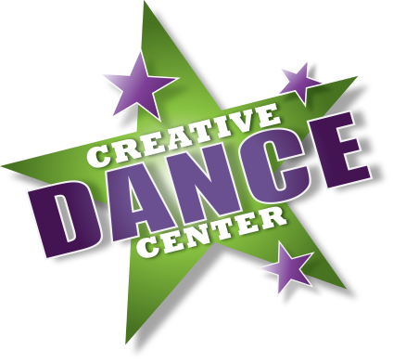
Visit us Online at
CDCdance.com
JANUARY NEWSLETTER
IN THIS ISSUE:
- Important Reminders
- Recent Highlights
- Upcoming Events

Welcome back to dance and Happy New Year!
CDC teachers and staff are looking forward to a wonderful 2017! Everyone is ready to get back into training and move forward to recital!
@CDCVA

Creative Dance Center Virginia

Reminders:
- CDC is OPEN on Monday, January 16th (Martin Luther King Jr Day). We are also open Friday, January 20th (Inauguration day).
- Please be sure to follow CDC on social media for the most up-to-date information on studio closures in the event of inclement weather!
- Please do your best hjto arrive a few minutes before your dancer’s class time. In these cold winter months, dancers will need time to transition from their outdoor gear into dance apparel!
- Don’t forget to label all items: Dance shoes, hats, gloves, scarves, and boots! Items left at the studio will be placed in our Lost and Found bins in the Girl’s dressing room.
Recent Highlights:
- Despite the icy conditions, the MOVE workshop was a success! Dancers enjoyed learning from top teachers and choreographers in the industry.
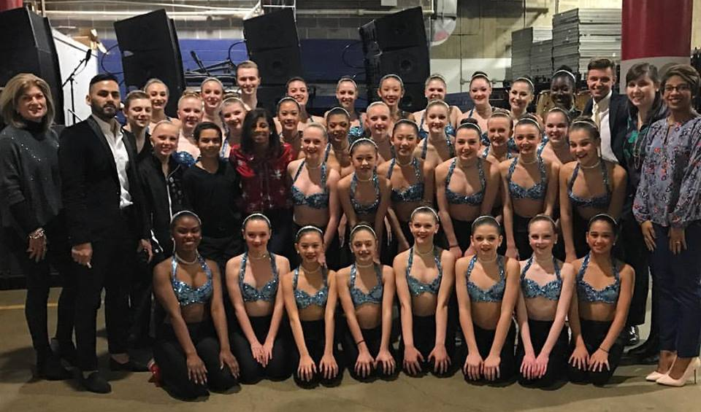
- TOKYO the COMPANY show, A Change Is Gonna Come, was utterly inspiring! CDC really enjoyed hosting the show. CDC*Stars parents and dancers did a fantastic job providing concessions and managing the lobby. Congratulations to everyone involved!
- CDC Competition Team brought down the house performing at the Verizon Center for the Washington Wizard’s game!! We are so proud of our dancers and teachers who represented CDC!!

Upcoming Events:
- CDC*Stars and some Classical Conservatory members are heading to JUMP Convention!
  - Wish our dancers luck as they endure rigorous training with top industry professionals in Washington DC January 13-15.
  - Special luck to our dancers who will compete their solo routines!
- Baby Ballerina presents: Lil’ Nutcracker on Sunday, January 15
  - Our littlest dancers have been working hard to showcase their talents in a special production!
    - Location: Eagle Ridge Middle School
    - Show times:
      - Sunday January 15 at 11:00am and 3:00pm
    - Tickets are just $5 – come support the future dance stars of CDC!
- Creative Dance Center presents the 2017 Winter Benefit Performance
  - Performances by CDC’s Classical Conservatory, Competition Team, STARS, and Performing Troupe
    - Saturday, February 4 at 6:00pm
    - Location: Stone Bridge High School
    - Presale Tickets $20 available online at IPAyouth.com or at any CDC location
    - Tickets available at the door for $25
  - Presented by IPAY to benefit the Malone Foundation, The Loudoun Abused Women’s Shelter and the Paxton Campus
- CDC is proud to host TOKYOthePRODUCTION’s Hip Hop Workshop!
  - Does your dancer love hip hop? This workshop will ignite their creativity and love of dance!
    - Location: CDC South Riding
    - February 25th and 26th
    - Registration deadline is January 20th – sign up today!!
